ILETU User Manual

The Different Views
There are many different views that can be accessed using the iLETU application. All of them are useful for finding out specific information about LeTourneau University whether you are a student or someone interested in the university.

About
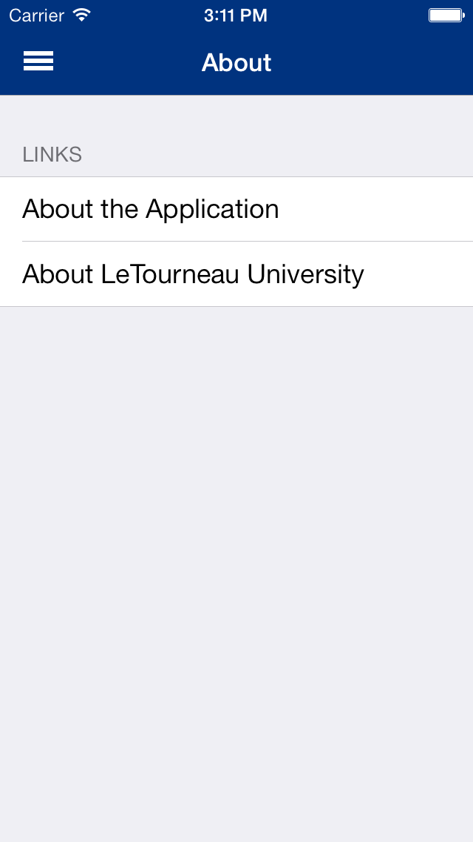

The About view allows you to select which of the About pages to view. If “About the Application” is selected, the page gives a little bit of information about who made and who maintains the application. If “About LeTourneau” is selected, the page gives a little information about LeTourneau University itself.
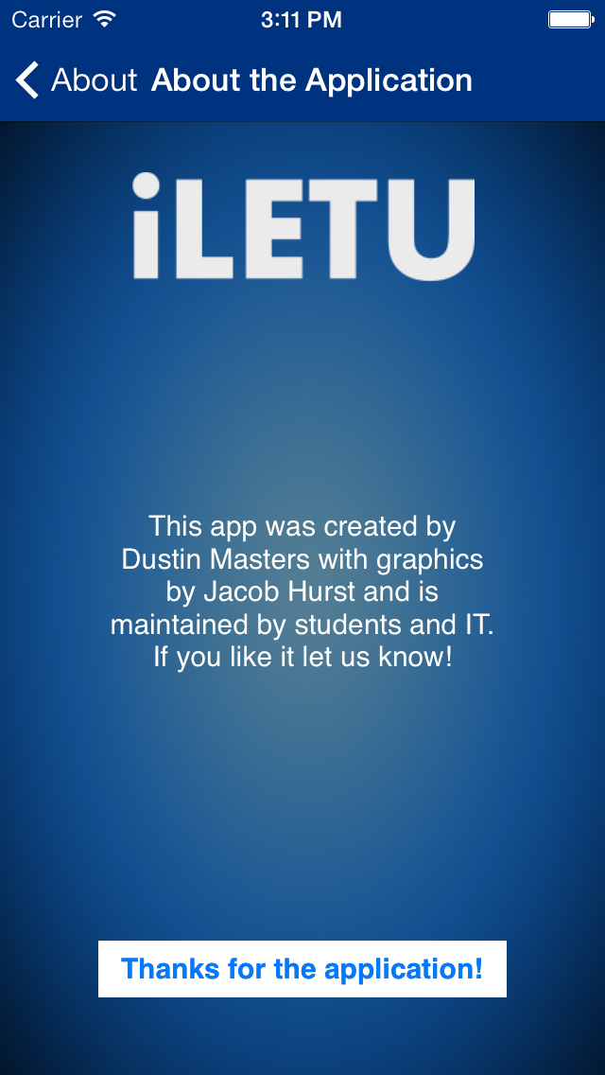

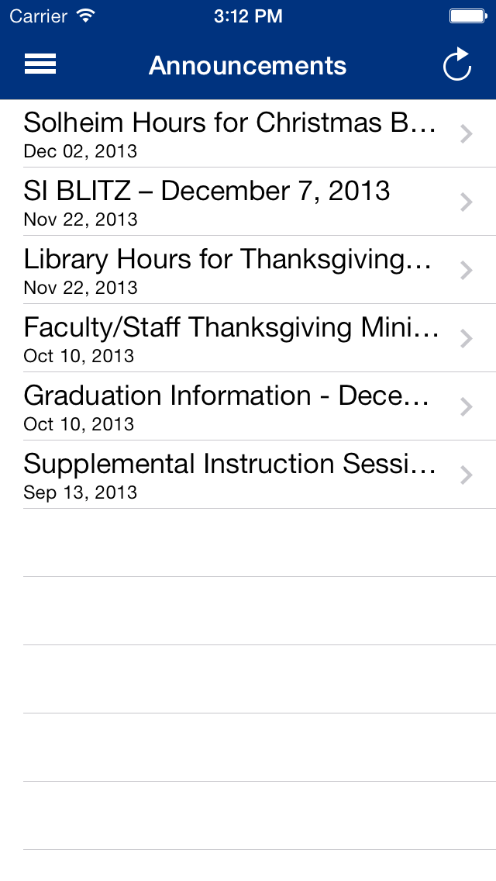
Announcements
The Announcements view allows you to view the announcements for the school. By selecting one, you can view the announcement in full.

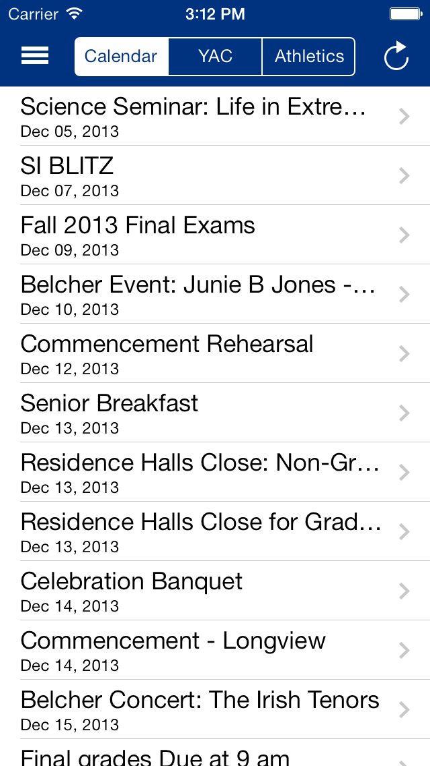
Calendar
The Calendar view allows you to view the calendars for the school, YAC, and the sports teams respectively. The different calendars can be viewed by selecting the appropriate button at the top of the view.

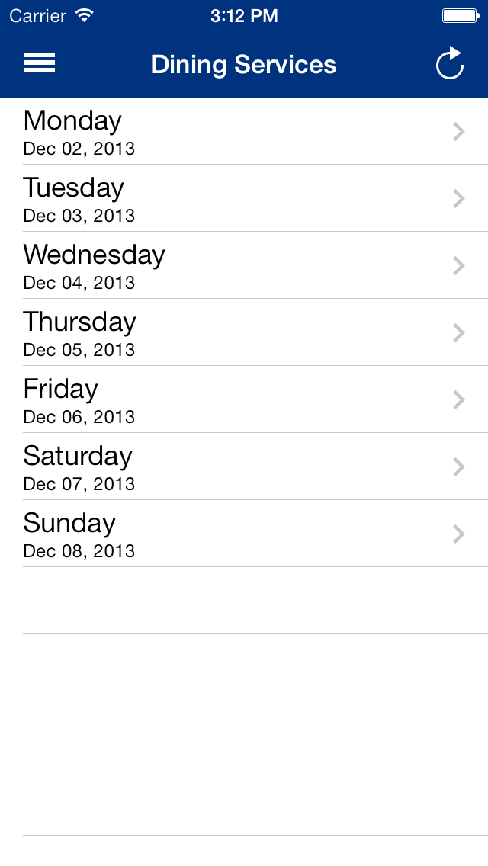

Dining Services
The Dining Services view allows you to view the menu for the week. By selecting the appropriate day, you can see what is offered for the day at the Corner Cafe.

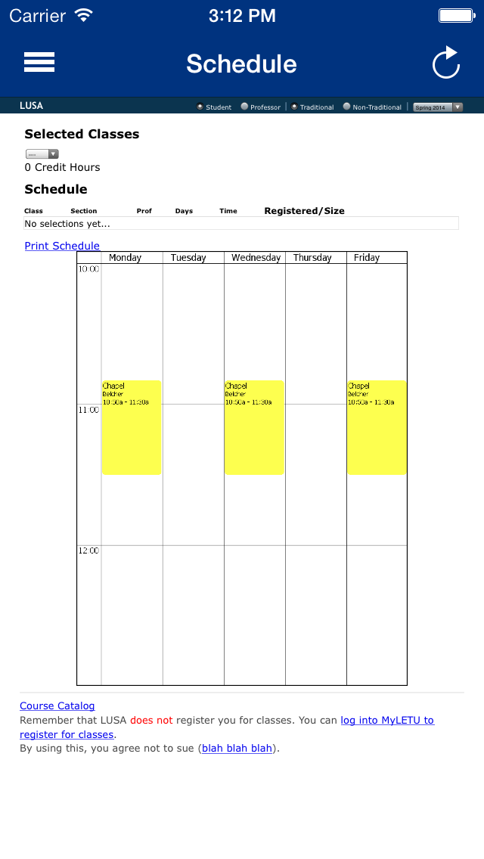
Schedule
The Schedule view allows you to create a visual representation of your schedule using LUSA. By selecting the department name in the top left and then selecting the correct course number next to it, a yellow block representing the class time will appear on the calendar. Once your schedule is completed, you may print it if desired.

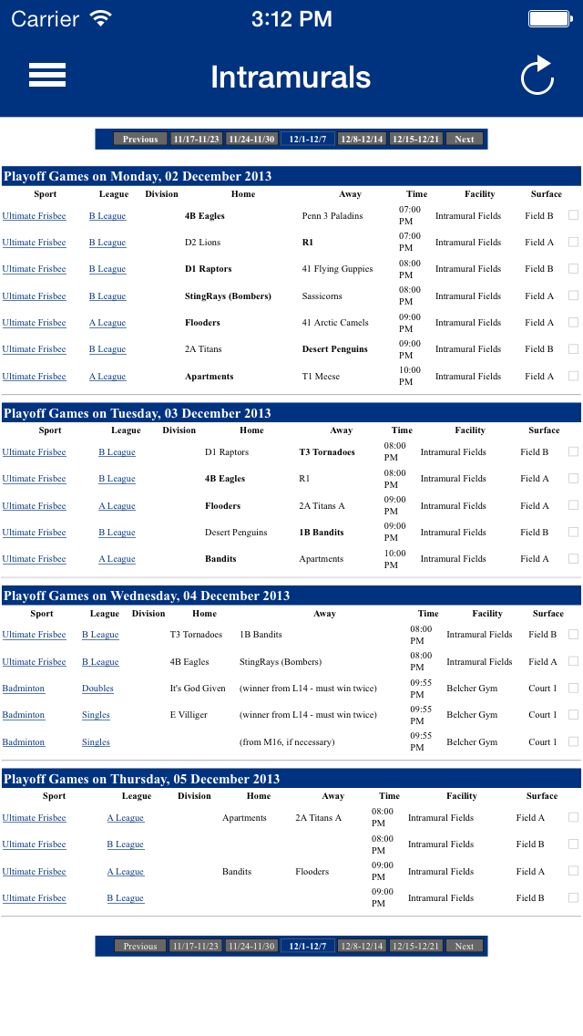

Intramurals
The Intramurals view allows you to view all of the
information concerning the intramurals at LeTourenau.

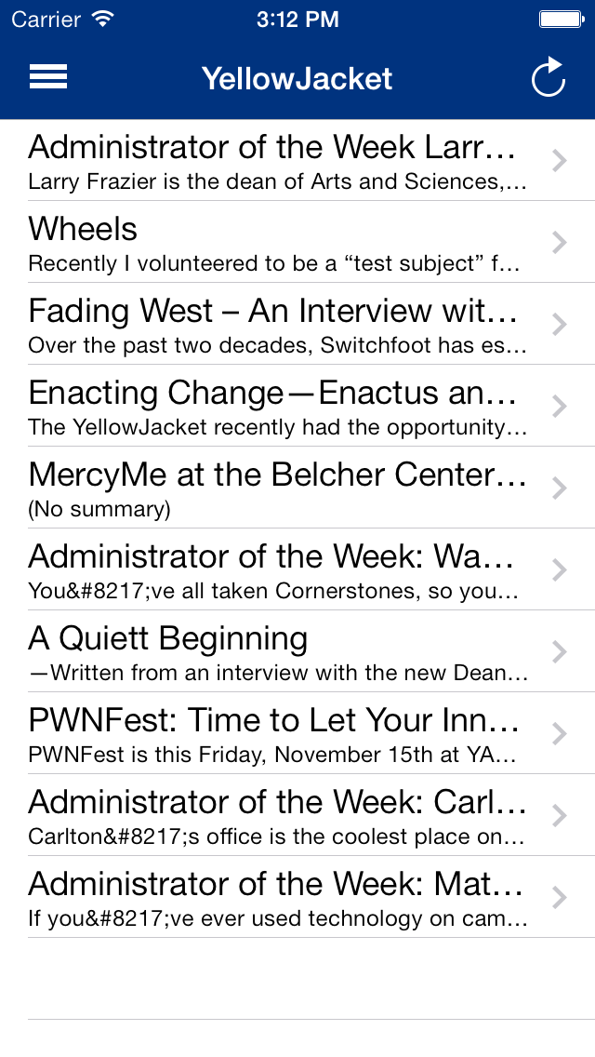
Yellowjacket
The Yellowjacket view allows you to view all of the articles in the Yellowjacket magazine. By selecting the title of the article, you can view the entire article in full.

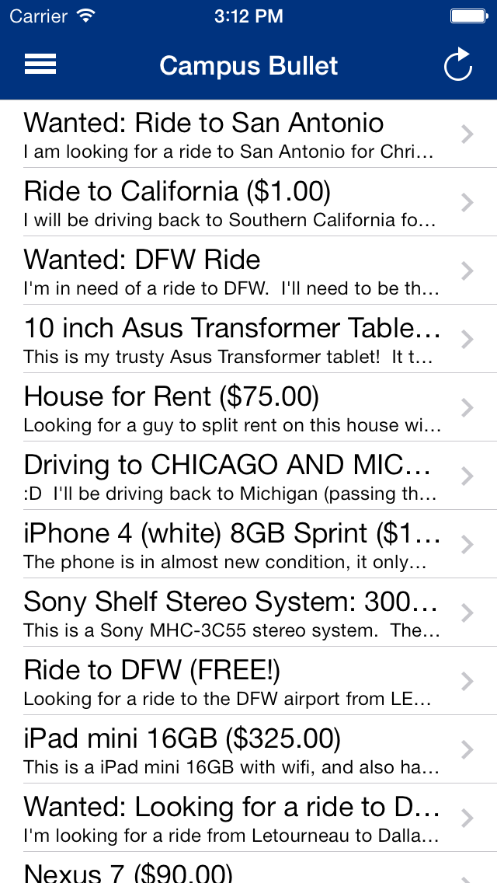

Campus Bullet
The Campus Bullet view allows you to view all of the items
currently posted on the Campus Bullet. By selecting an
item, you can view the entire posting.

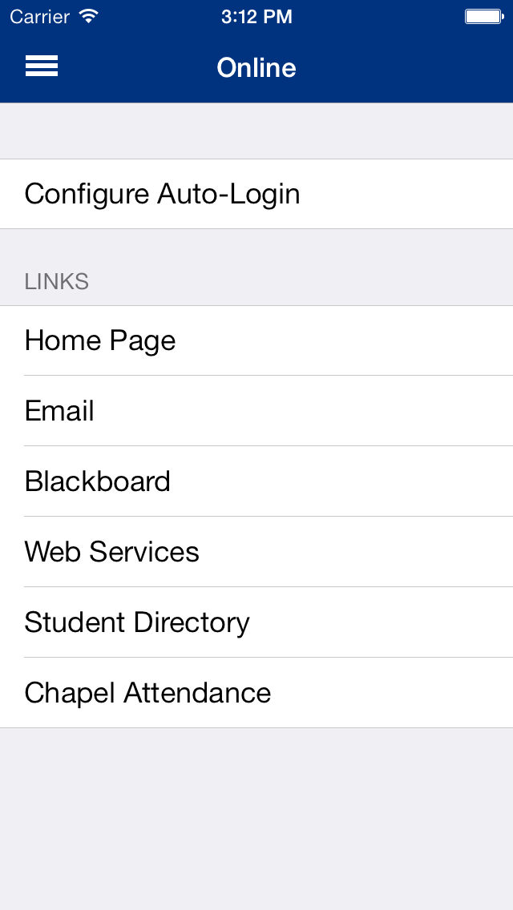
Online
The Online view allows you to access all of the important web pages concerning LeTourneau University. If “Configure Auto-Login” is selected, you can set your username and password to be automatically entered in all of the pages that require them. By selecting any of the other buttons, you will be shown the appropriate web page from whence you can use all of the features of each page.

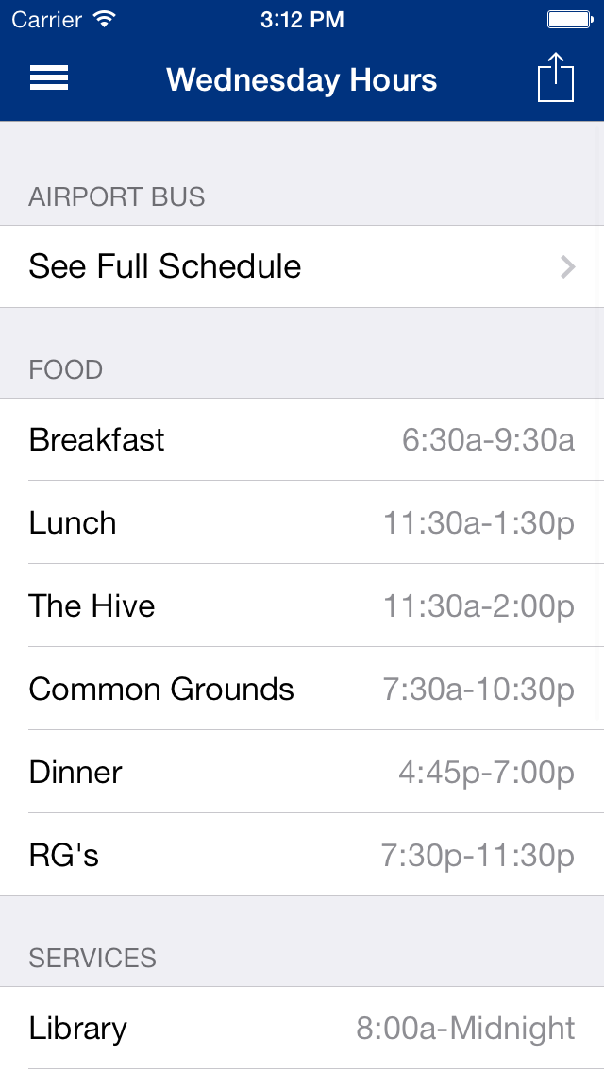
Hours
The Hours view allows you to view the hours of all of
the buildings on campus. The hours automatically
change to show the appropriate hours for the current
day. By selecting one of the buttons, you can view
either the full bus schedule or the hours for Solheim.

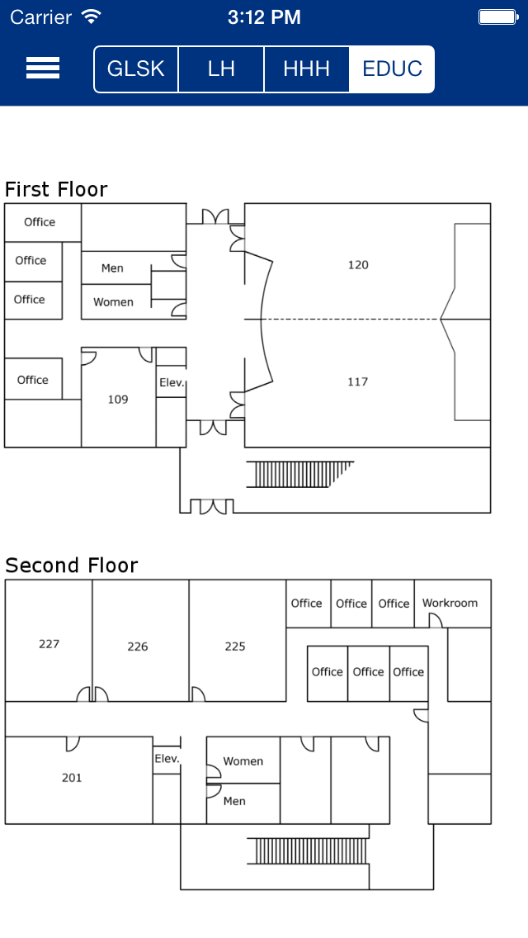
Floorplans
The Floorplans view allows you to view the layout for all of the academic buildings. You can switch the floorplans by selecting the button at the top with the correct abbreviation.

